英语专业3套试题
Topics for Speech Contest for English Majors

Test 1
Part I Presentation (3 minutes)
Task:
-- You are required to talk about the figure, describing and comparing what you have seen.
-- You’ll have 3 minutes for preparation. You must complete your presentation in 3 minutes.

Part II Interview (3 minutes)
Now you see a menu of a restaurant.

Express Delivery
Inexpensive Eats & Prompt Service
Tel: (212) 759---7070 / 7553 / 7554 986 2nd Ave
Catering Available for Home & Office Parties
Mon.---Sun. 10:00 A.M---12:00 A.M
1 Roast Duck------------------------- ¥40.00/kilogram
2 Varieties of Noodles, Dumplings Soup-------¥5.00
3 New Special Over Rice Platters
Shrimp with Vegetable Over Rice------------¥4.50
Chicken with Vegetable Over Rice----------¥4.50
Beef with Tomato Over Rice-----------------¥4.50
Tofu with Vegetable Over Rice---------------¥4.50

Task:
- Suppose you are the waiter of this restaurant.
- A customer comes to ask you for information about your restaurant. Be prepared to answer his or her questions.

-----------------------------------------------(Sample questions)------------------------------------------

Test 2
Part I Presentation (3 minutes)
Task:
-- You are required to talk about the figure, describing and comparing the cost of a project.
-- You’ll have 3 minutes for preparation. You must complete your presentation in 3 minutes.

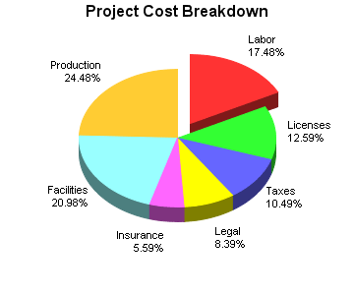

Part II Interview (3 minutes)
Now you see a notice.

Course Title: Word-processing and email
Date: 14-17 July.
Time:10:00-16:00 each day (10:00-12:30 and 13:30-16:00)
Location: Room 12 in Office Building
Target Groups: Staff in Finance, Marketing and Sales Departments with little experience
Numbers: Maximum 9
Tutor: Janet Harrod from Wordwise Training Company

You are welcome to attend the course.
Task:
- Suppose you are the organizer of this course.
- A staff comes to ask you for information about this course. Be prepared to answer his or her questions.

-----------------------------------------------(Sample questions)------------------------------------------

Test 3
Part I Presentation (3 minutes)
Task:
-- You are required to talk about the figure, describing and comparing the sales changes of two companies.
-- You’ll have 3 minutes for preparation. You must cminutes.
.
Part II Interview (3 minutes)
Now you see an announcement.

Course title: Advanced word-processing and spreadsheets
Date: 20-21 January
Time: 9:30-12:00 and 13:00-15:00 each day
Location: Ace Training Company Offices.
Transportation: Provided, leaving at 9:00 each day and returning at 15:30
Target group: Secretaries and junior managers
Numbers: Maximum 8
Tutor: Ace Training Company

Task:
- Suppose you are the organizer of this course.
- An employee comes to ask you for information about this course. Be prepared to answer his or her questions.

-----------------------------------------------(Sample questions)------------------------------------------

